INSERT INTO CHEQUE (CHEQUE_CODE, APARTMENT_CODE, ACCOUNT_CODE, PAYMENT_DATE, SUBMITTED_BY)

VALUES (1, 1, 1, '01.01.2021', 17000)

INSERT INTO CHEQUE (CHEQUE_CODE, APARTMENT_CODE, ACCOUNT_CODE, PAYMENT_DATE, SUBMITTED_BY)

VALUES (2, 1, 2, '01.02.2021', 13500)

INSERT INTO CHEQUE (CHEQUE_CODE, APARTMENT_CODE, ACCOUNT_CODE, PAYMENT_DATE, SUBMITTED_BY)

VALUES (3, 2, 3, '01.01.2021', 7500)

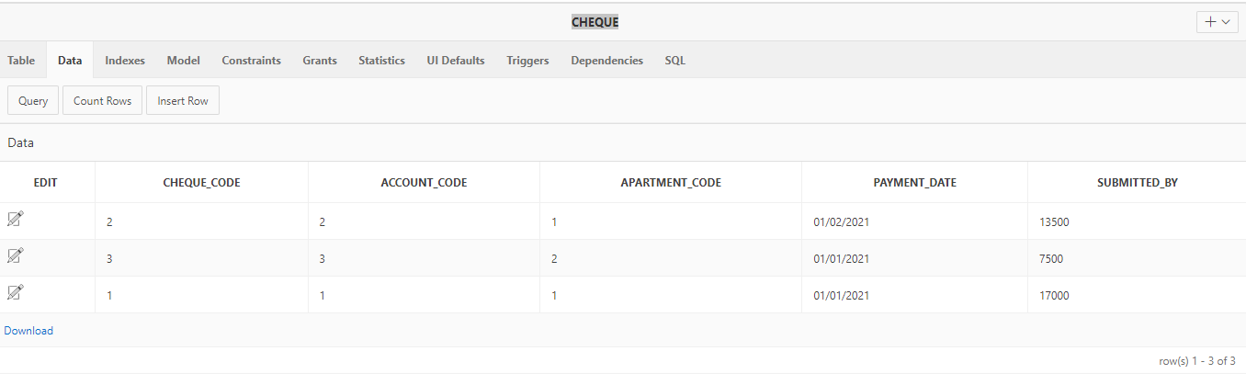

1. Взносы квартиросъёмщиков

SELECT FULL_NAME_TENANT, PAYMENT_DATE, SUBMITTED_BY FROM APARTMENT

INNER JOIN CHEQUE

ON APARTMENT.APARTMENT_CODE = CHEQUE.APARTMENT_CODE

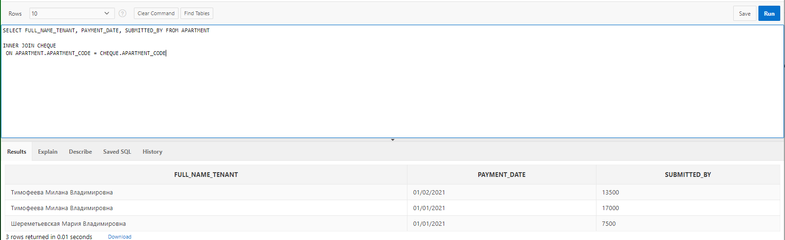

1. Дата прихода квитанции и дата оплаты услуги

SELECT FULL_NAME_TENANT, PAYMENT_DATE, "Date" FROM APARTMENT

INNER JOIN MONTHLY_INVOICE

ON APARTMENT.APARTMENT_CODE = MONTHLY_INVOICE.APARTMENT_CODE

INNER JOIN CHEQUE

ON MONTHLY_INVOICE.ACCOUNT_CODE = CHEQUE.ACCOUNT_CODE

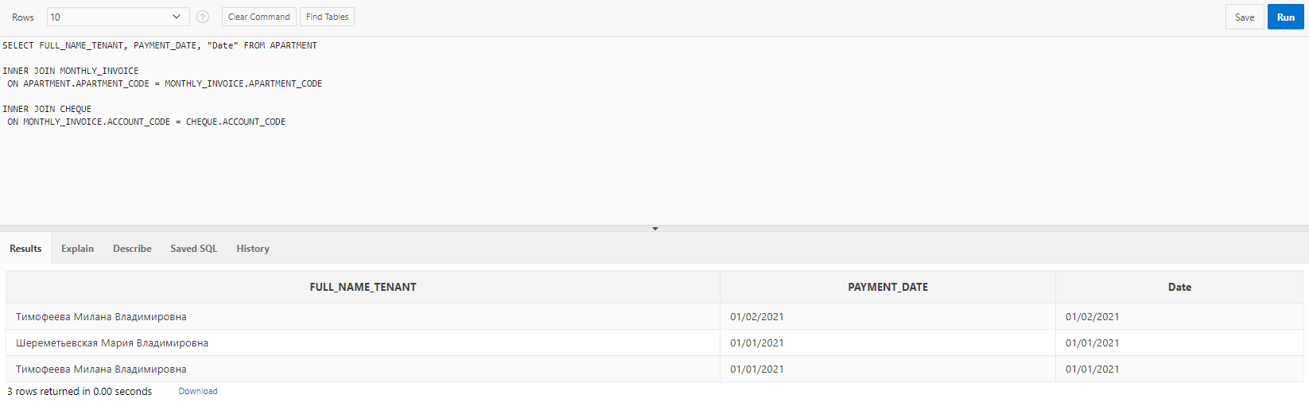

1. Сколько нужно внести и сколько внесено

SELECT FULL_NAME_TENANT, TOTAL, SUBMITTED_BY FROM APARTMENT

INNER JOIN MONTHLY_INVOICE

ON APARTMENT.APARTMENT_CODE = MONTHLY_INVOICE.APARTMENT_CODE

INNER JOIN CHEQUE

ON MONTHLY_INVOICE.ACCOUNT_CODE = CHEQUE.ACCOUNT_CODE

